Your Paper's Title Starts Here: Please Center
use Times New Roman 14

ZHANG Xiaosan, LI Xiaosi, Michael B. Johnson

ZHANG Xiaosan
Associate Professor
School of Economics and Management
Tsinghua University
Beijing 100084, China
Phone: (8610) 6277 7777
Email: zhangxs@sem.tsinghua.edu.cn

LI Xiaosi *
Master’s student
Department of Statistics and Actuarial Science
University of Hong Kong
Room1001, Meng Wah Complex, HKU,
Pokfulam Road, Hong Kong
Phone: (852)2855 5555
Email: lixs@hku.hk

Michael B. Johnson
Ph.D. Candidate
Department of Risk management and Insurance
Temple University
1800 Liacouras Walk, 600 Alter Hall
Philadelphia, PA 19100
Phone: (215) 200 0000
Email: mjohnson@temple.edu

Keywords: Publisher, Designing, Lowercase letters.
Abstract. This document explains and demonstrates how to prepare your paper for Proceedings of CICIRM 2025. The best is to read these instructions and follow the outline of this text. The text area for your paper must be 17 cm wide and 25 cm high (6.7 and 9.8 inches, resp.). Do not place any text outside this area.

- 引言
为了顺利、高质量地做好本次会议论文集的出版工作，本文给出了论文的格式要求，请各位作者务必按照本文给出的论文格式要求编辑、排版您的论文，以使得您的论文能顺利入选会议论文集。在此大会组委会非常感谢您的配合和支持。
2．论文格式
本文以MS Word 2003版平台为例具体给出了论文格式说明。
2.1 页面设置
纸型：A4 (宽21厘米，高29.7厘米)。
页边距：上2.5厘米，下2厘米，左2厘米，右2厘米。
2.2 行距设置
全文的行距设定为单倍行距，段落首行缩进2字符。
2.3 字体设置
2.3.1 题头区：每篇论文第一页键入英文题目、作者姓名、工作单位、通讯地址、联系方式、关键词、摘要；每篇论文的最末页键入中文题目、作者姓名、工作单位、通讯地址、联系方式、关键词、摘要。
2.3.2 英文部分字体规定如下：
论文题目⎯14磅Times New Roman加粗居中，段前60磅，段后6磅；作者姓名⎯14磅Times New Roman居中；工作单位及通讯地址⎯11磅Times New Roman居中，段前6磅；“关键词”⎯11磅Times New Roman加粗、关键词内容11磅Times New Roman；“摘要”⎯12磅Times New Roman加粗、摘要内容12磅Times New Roman；“参考文献”12磅Times New Roman加粗，“参考文献”内容12磅Times New Roman。
2.3.3 中文部分字体规定如下：
论文题目⎯16磅宋体加粗居中；作者姓名⎯14磅宋体居中；工作单位及通讯地址⎯11磅宋体居中；“关键词”⎯11磅宋体加粗、关键词内容11磅宋体；“中文摘要”⎯12磅宋体加粗、摘要内容12磅宋体；
2.3.4各级各类标题规定如下：
一级和二级标题⎯12磅宋体加粗顶格；三级及三级以下标题和正文⎯12磅宋体；表名、图名⎯10磅宋体，居中，段前段后各6磅；表文、图文⎯10磅宋体，表和图都从1号开始编号；“引理”、“定理”等⎯缩进2字符宽后，用10磅宋体，再空1字符宽，开始正文。
参考文献内容12磅Times New Roman。
2.4 图与表
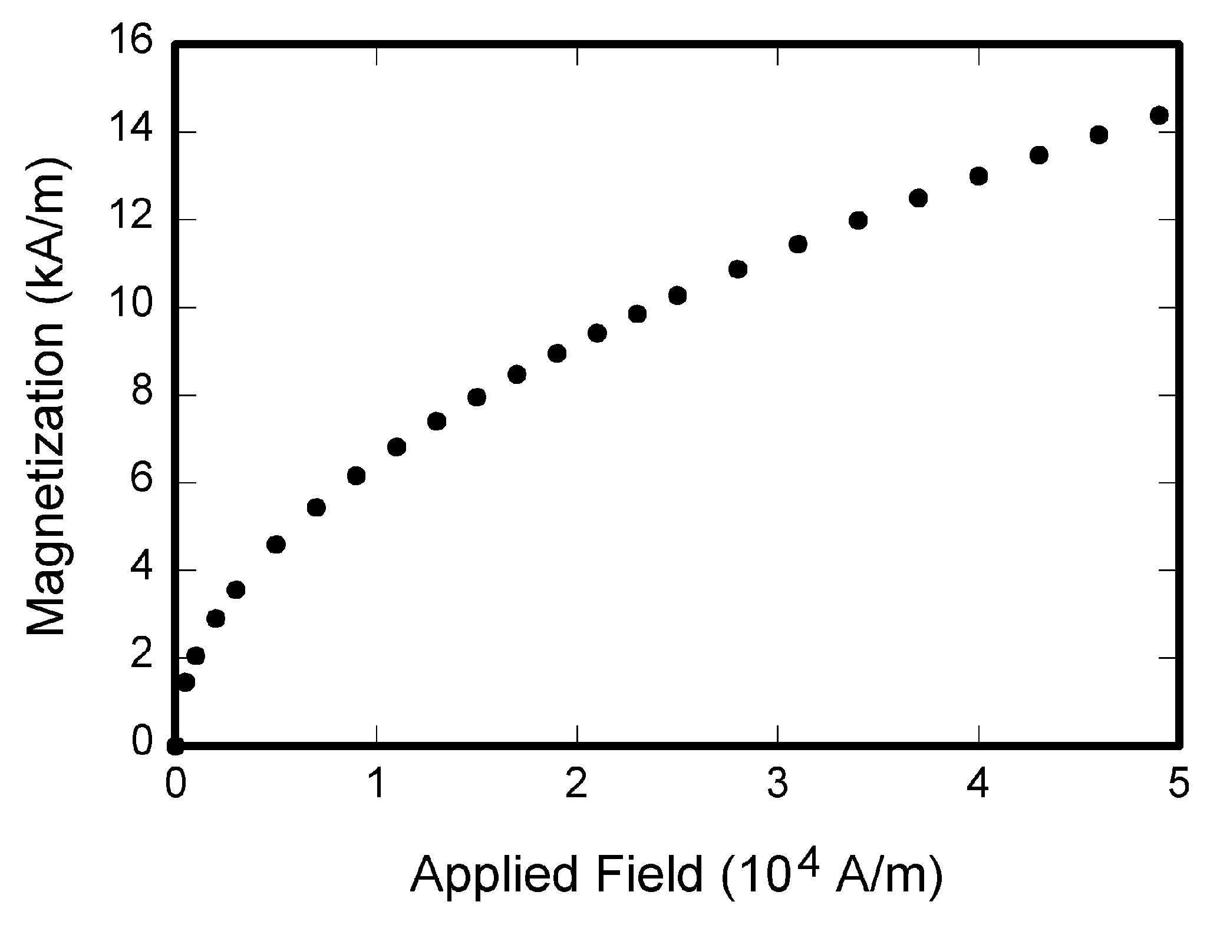
图1 图名应为图的相应说明性文字

表1 表名应为表的相应说明性文字
表题 | 分栏表题
表题 | 小标题 | 小标题 | 小标题
1
2
3
4
5

图与表的宽度不要超过栏宽。图名应该居中放在图的下面，表名应该居中放在表的上面。避免将图或表放在提及的段落之前。
图与表的精度不能低于300dpi，须保证图片的清晰度。
2.5 数学公公式和符号
公式必须用公式编辑器编辑，不能使用截图，居中排版，以公式编辑器为例说明如下：
函数、变量采用斜体，矩阵向量采用粗斜体。
尺寸标准为10磅，上下标6磅，次上下标5磅，符号14磅，次符号9磅。
(1)
(2)
每一个公式应给以适当编号，公式编号右对齐。公式段前段后6磅。
3．注意事项
论文全文不要加页码。
页面必须严格按照本文的要求设置，严禁在页边距的空白区域出现任何文字、符号或图表的一部分。
如果遇到本文没有涉及的论文格式问题，作者可首先参阅本届大会网页提供的“英文论文格式”要求。若“英文论文格式”也没有涉及该问题，作者可以采纳其它学术论文的惯例。
一种简便易行的排版方式为：首先，将论文内容粘贴至本模板；其次，格式刷所粘贴的内容；最后，删除模板原有内容。如此，可保持纸型、页面设置、字体、行间距等格式不变。
4．结束语
下面“参考文献”部分，要求只用英文呈现。如原参考文献为中文，请务必翻译成英文，且只保留英文译文，并标注“（in Chinese）”。
致谢
资助信息的英文版放在文章首页的注脚位置，中文版的资助信息及其它致谢信息置于文章末尾和参考文献之间。致谢的正文部分采用与文章正文相同的格式。例如：本文为国家社科基金一般项目《XXXX研究》(xxxxxxx)的阶段性成果之一。
References

- CRA WFPRD W, GORMAN M. Future libraries: dreams, madness, & reality [M]. Chicago: American Library Association, 1995
- O’BRIEN J A. Introduction to information systems [M]. 7th ed. Burr Ridge, III: Irwin, 1994.
- BABU B V, NAGAR A K, DEEP K, et al. Proceedings of the Second International Conference on Soft Computing for Problem Solving, December 28-30, 2012[C]. New Delhi: Springer, 2014.
- CALKIN D, AGER A, THOMPSON M.A comparative risk assessment framework for wildland fire management: the 2010 cohesive strategy science report: RMRS-GTR-262[R]. [S.I.: s.n.], 2011:8-9.
- CALMS R B．Infrared spectroscopic studies on solid oxygen[D]．Berkeley：University of California，1965．
- PEEBLES P Z, Jr. Probability, random variable, and random signal principles [M]. 4th ed. New York; McGraw Hill, 2001.
- YUFIN S A. Geoecology and computers: proceedings of the Third International Conference on Advances of Computer Methods in Geotechnical and Geoenvironmental Engineering, Moscow, Russia, February 1-4, 2000 [C]. Rotterdam: A. A. Balkema, 2000.
- BALDOCK P. Developing early childhood services: past, present and future [M/OL]. [S.I.]: Open University Press, 2011: 105 [2012-11-27]. http:// lib. myilibraty .com/Open.aspx? id = 3 12377.
- FAN X, SOMMERS C H. Food irradiation research and technology. 2nd ed. Ames, Iowa: Blackwell Publishing, 2013: 25-26 [2014-06-26]. http://onlinelibraty.wiley.com/doi/10/1002/9 781118422557.ch2/summary.
- WEINSTEIN L, SWERTZ M N, Pathogenic properties of invading microorganism [M]// SODEMAN W A, Jr, SODEMAN W A. Pathologic physiology, mechanisms of disease. Philadelphia: Saunders, 1974:745-772.
- ROBERSON J A, BURNESON E G. Drinking water standards, regulations and goals [M/OL] // American Water Works Association. Water quality & treatment: a handbook on drinking water. 6th ed. New York: McGraw-Hill, 2011: 1.1-1.36 [2012-12-10]. http://lib.myilibraty.com/Open. aspx? id=291430.
- American Association for the Advancement of Science. Science [J]. 1883, 1(1)-. Washingten, D.C.: American Association for the Advancement of Science, 1883-.
- KANAMORI H. Shaking without quaking [J]. Science, 1998, 279(5359): 2063.
- CAPLAN P. Cataloging internet resources [J]. The public access computer systems review, 1993, 4(2):61-66.
- FREES K S, KATUS H A, MEDER B. Next-generation sequencing: from understanding biology to personalized medicine [J/OL]. Biology, 2013, 2(1): 378-398 [2013-03-19]. http:// www. Mdpi.com/2079-7737/2/1/378. DOI:10.3390 /biology2010378.
- MYBURG A A, GRATTAPAGLIA D, TUSKAN G A, et al. The genome of Eucalyptus grandis [J/OL]. Nature, 2014, 510: 356-362 (2014-06-19) [2014-06-25]. http: //www.nature.com/ nature/ journal/v510/n7505/pdf/nature13308.pdf.DOI: 10.1038/ nature13308.
- TACHIBANA R, SHIMIZU S, KOBAYSHI S, et al. Electronic watermarking method and system: US6915001 [P/OL].2005-07-05[2013-11-11]. http: // www.google.co.in/patents/US 69 15001.
- Online Computer Library Center, Inc. About OCLC: history of cooperation [EB/OL]. [2012 -03 -27]. http: //www.oclc.org/about/cooperation.en.html.
- HOPKINSON A. UNIMARC and metadata: Dublin core [EB/OL]. (2009-04-22) [2013-03-27]. http: //archive.ifla.org/ IV/ ifla64/138-161e.htm.
- RUDDOCK L. Economics for the modern built environment [M/OL].London: Taylor & Francis, 2009: 12 [2010-06-15]. http: // lib.myilibrary.com/Open, aspx? id=179660.
- DUNBAR K L, MITCHELL D A. Revealing nature’s synthetic potential through the study of ribosomal natural product biosynthesis[J/OL]. ACS chemical biology, 2013, 8: 473 – 487 [2013 -10-06]. http: // pubs.acs.org/ doi/pdfplus / 10.1021/cb3005325.
- WEINER S. Microarchaeology: beyond the visible archaeological record[M/OL]. Cambridge, Eng.: Cambridge University Press Textbooks, 2010: 38 [2013-10-14]. http: // lib.myilibrary. com /Open, aspx? id=253897.
- DEVERELL W, IGLER D. A companion to California history[M/OL]. New York: John Wiley & Sons, 2013: 21-22 (2013-11-15) [2014-06-24]. http: // onlinelibrary. Wiley. com / doi /10.1002 /9781444305036.ch2 /summary.
- DES MARAIS D J, STRAUSS H, SUMMONS R E, et al. Carbon isotope evidence for the stepwise oxidation of the Proterozoic environment [J]. Nature, 1992, 359: 605-609.
- WALLS S C, BARICHIVICH W J, BROWN M E. Drought, deluge and declines: the impact of precipitation extremes on amphibians in a changing climate[J/OL]. Biology, 2013, 2 (1): 399-418 [2013-11-04]. http:// www.mdpi.com/2079-7737/2/1/399. DOI: 10.3390/ biology2010399.
- FRANZ A K, DANIELEWICZ M A, WONG D M, et al. Phenotypic screening with oleaginous microalgae reveals modulators of lipid productivity [J/OL]. ACS Chemical biology, 2013, 8: 1053-1062 [2014-06-26]. http:// pubs.acs.org/doi/ipdf/10.1021/cb300573r.
- PARK J R, TOSAKA Y. Metadata quality control in digital repositories and collections: criteria, semantics, and mechanisms[J/OL]. Cataloging & classification quarterly, 2010, 48(8): 696-715 [2013-09-05]. http:// www. Tandfonline.com/doi/pdf/10.1080/01639374.2010.5.8711.
- Commonwealth Libraries Bureau of Library Development. Pennsylvania Department of Education Office. Pennsylvania library laws[EB/OL]. [2013-03-24]. http: // www. racc. Edu / yocum/ pdf/ PALibraty Laws. pdf.
- Dublin core metadata element set: version 1.1 [EB/OL]. (2012-06-14)[2014-06-11]. http:// dublineore.org/documents/dces/.
- XIONG P, WU X. Discussion on how to construct benign medicine circulation mechanism from tranaction cost perspective [J]. China price, 2005 (8):42-45.（in Chinese）
- WANG H. Research On Insurance In Big Data Era[M]. Beijing：China Financial Publishing House, 2014.（in Chinese）
[32] LIU S F, YANG Y J, WU L F, et,al. Gray System and Its Theoretical Application[M]. 7th ed. Beijing：Science Press, 2015.（in Chinese）
[33]WAN F. Research on Japanese Life Insurance Industry [M]. Beijing：China Financial Publishing House, 2014.（in Chinese）
[34]LIU B. Research on the Promotion of Scientific and Technological Progress to the Development of Insurance Industry [D]. Taiyuan：Shanxi University, 2008.（in Chinese）
[35]Research Group of Shanghai Food and Drug Administration. A study on online pharmaceutical operating situation and supervision mechanism [J]. Shanghai food and drug information research, 2008(1):8-11（in Chinese）

中文文章标题

张小三 李晓四 Michael B. Johnson

张小三
副教授
清华大学经济管理学院
北京100084，中国
电话: (8610) 6277 7777
Email: zhangxs@sem.tsinghua.edu.cn

李晓四*
硕士生
香港大学统计及精算学系
香港大学明华综合大楼1001室
香港薄扶林道
电话:(852)2855 5555
Email: lixs@hku.hk

Michael B.Johnson
博士生
天普大学风险管理与保险系
Liacouras1800号，阿尔特区600
费城，PA19100
电话:(215) 200 0000
Email: mjohnson@temple.edu

关键词: 格式要求; 论文; 会议
中文摘要. 给出了本次会议正式论文的出版要求，请各位作者严格按照要求，认真编辑、排版您的论文。为中文为主体的论文，须有中、英文的标题、中、英文的作者姓名（英文姓名可以是汉语拼音）、中、英文的单位及通讯地址、中、英文的摘要、中、英文的关键词。

